MASSEE
7th International Congress on Mathematics
7th MICOM 2026
April 24 –26, 2026
Thessaloniki, Greece

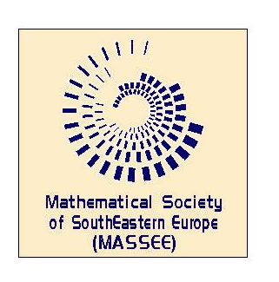 | Organizers  Mathematical Society of  South-Eastern Europe  and  Hellenic Mathematical Society  Branch of Central Macedonia HMS | 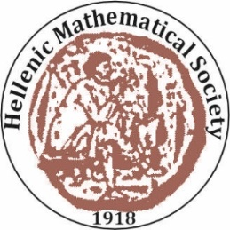

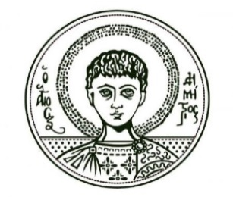 | and  The Department of Mathematics,  Aristotle University of Thessaloniki

EXPRESSION OF INTEREST

Name:_____________________________________________________________
(title) (surname) (name)

Affiliation:___________________________________________________________

Mailing address:______________________________________________________

E-mail:_____________________________________________________________

Tel _____________________________

I plan to present a paper: YES NO NOT SURE
Please specify possible theme from the list or suggest another:
___________________________________________________________________

I plan to organize a session or workshop:

YES NO NOT SURE
Please specify theme:
___________________________________________________________________

Send this form by 10th February 2026 to:
Organizing Committee
Hellenic Mathematical Society
Email to: info@hms.gr

